Grade 7 Accelerated · Unit 4 · Lesson 5  Evaluating Expressions with Radicals  Question Bank 4.05 ANSWER KEY | Name  Date  Period

Show your work. Circle your final answer.
For questions 1 through 6, evaluate.
1. 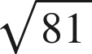
9

2. 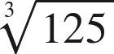
5

3. 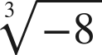
−2
An odd root keeps the sign of its radicand.

4. 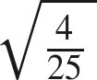
The numerator and the denominator each get the root.

5. 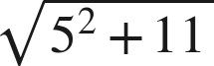
6
Finish under the bar: 25 + 11 = 36.

6. 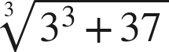
4
27 + 37 = 64.

For questions 7 and 8, evaluate. Each expression has a power and a radical.
7. Evaluate each expression.
a. 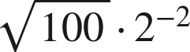
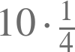.
b. 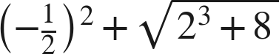

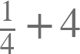.
c. 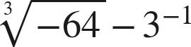
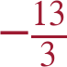
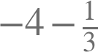.

8. Evaluate each expression.
a. 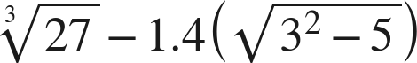
0.2
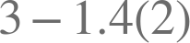.
b. 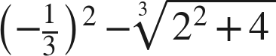
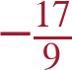
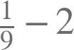.
c. 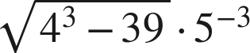

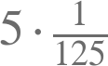.

Working backwards.
9. Find the value of that makes each statement true. (The radicand is the unknown here, so it is not one of the listed perfect values until you find it.)
a. 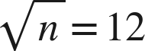
n = 144
b. 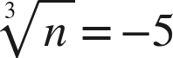
n = −125
c. 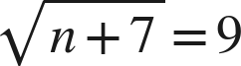
n = 74
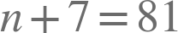.

Reading someone else's work.
10. Tonya writes 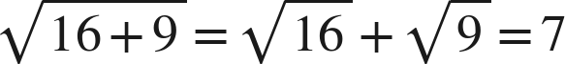. Evaluate the expression correctly, and explain in one sentence what the radical bar does that her method ignores.
. The bar groups 16 + 9 into a single radicand, so the addition is finished before any root is taken.
Her method would need the root of a sum to equal the sum of the roots, and it does not.

11. Which is the value of 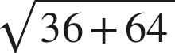 ?
○ A. 14
○ B. 100
● C. 10
○ D. 50
C

12. Select ALL of the expressions whose value is 3.
☐ A. 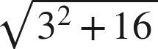
☒ B. 
☒ C. 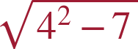
☒ D. 
☐ E. 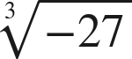
☒ F. 
B, C, D and F
C's radicand is 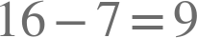 and B's is .

